Linux Assignment 02

1. Created user with name Techie and also provided sudo access to user.
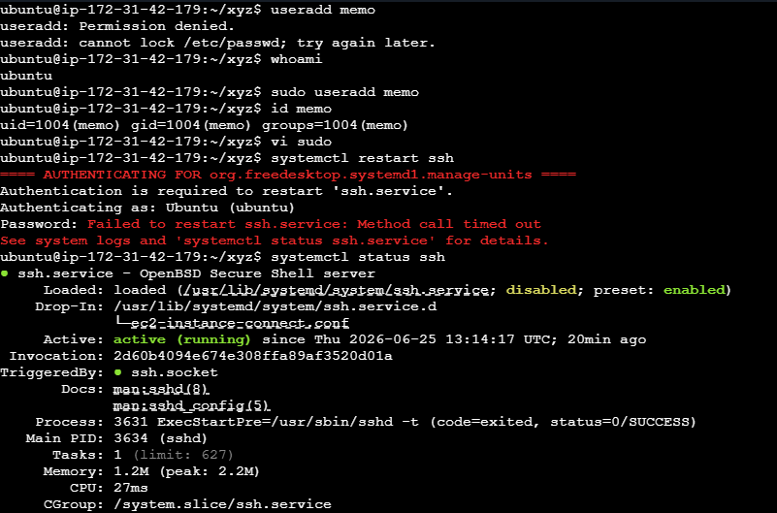

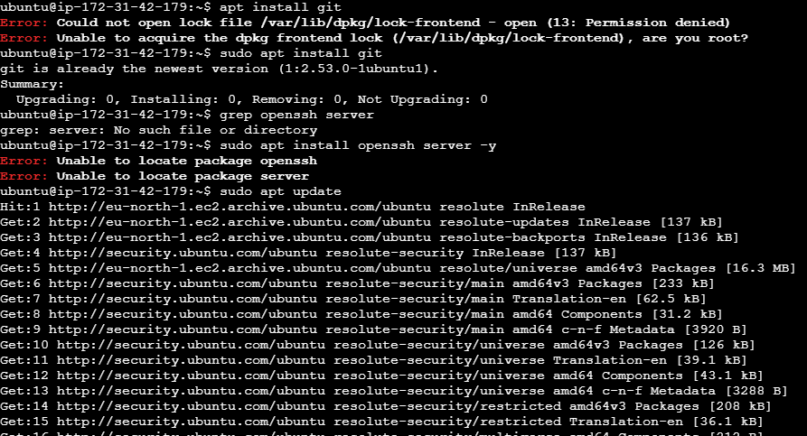
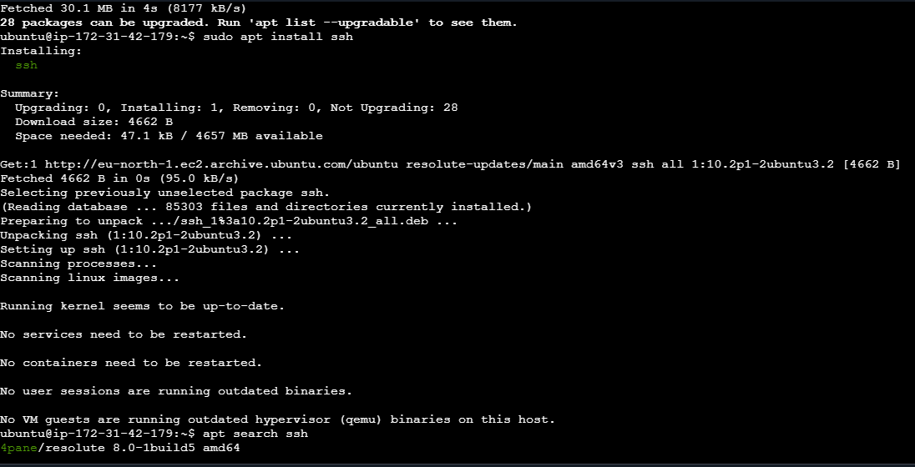

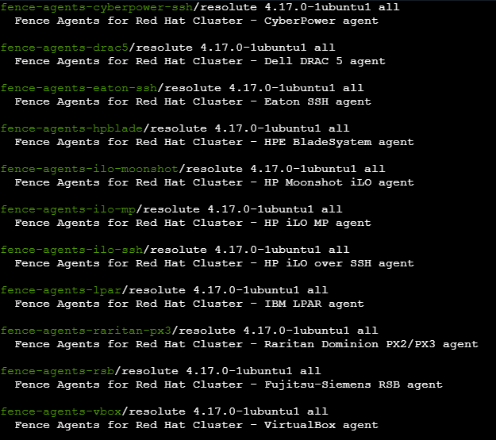

2. Navigate to the home directory.
3. Create a new directory.
4. List the contents of a directory.
5. Change the current directory.
6. Create a new empty file.
7. View the contents of a file.

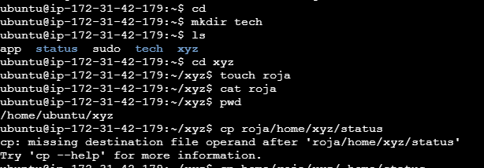

8. Copy a file to another location.

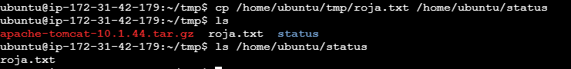

9. Move a file to another location.

10. Rename a file.
11. Delete a file.
12. Grant or revoke permissions on a file or directory.

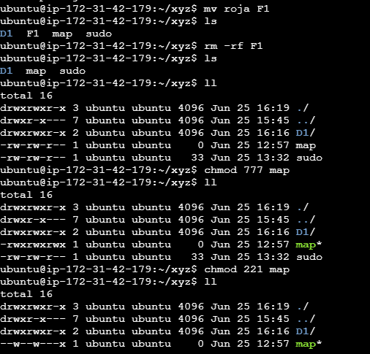

13. View the current date and time.
14. Check the system uptime.

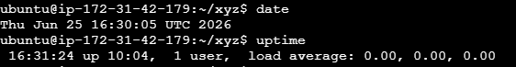

15. View the running processes.

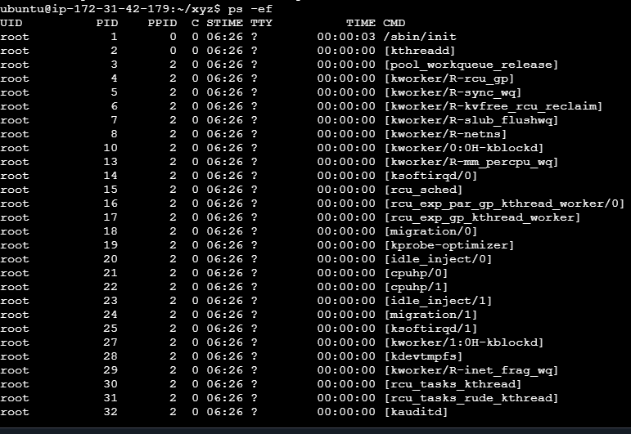

16. Kill a running process.

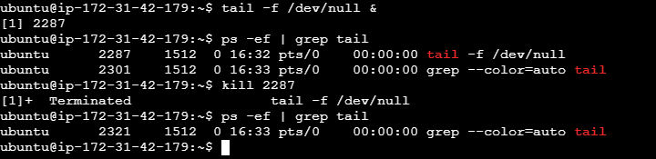

17. Update the system packages.
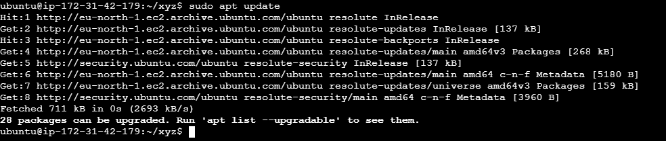
18. Install a package using the package manager (e.g., apt or yum).

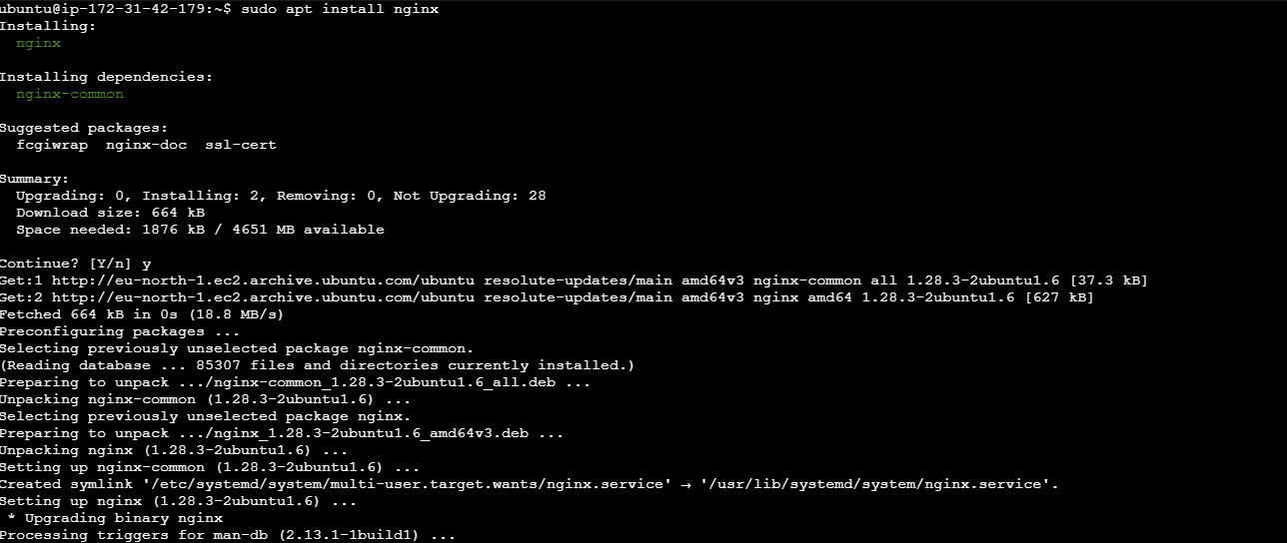
19. Update the system packages.

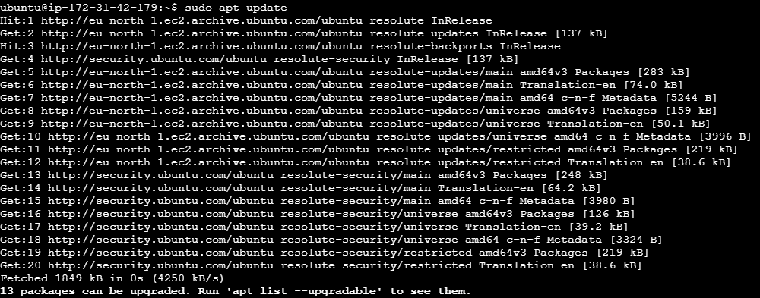

20. Create a symbolic link
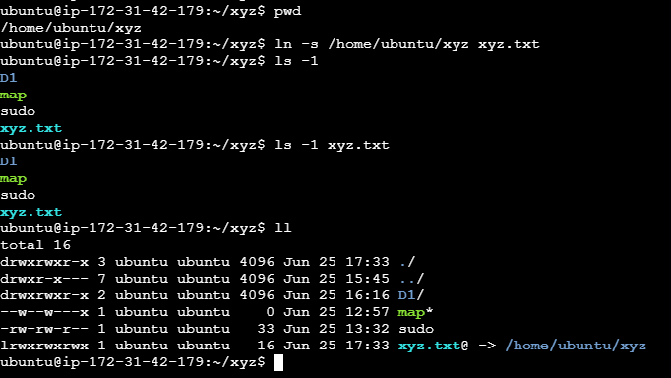
21. Searched for the files using the find command that are modified today
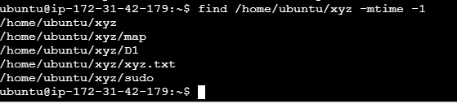

22. Monitor system resources with top or htop.
Using top

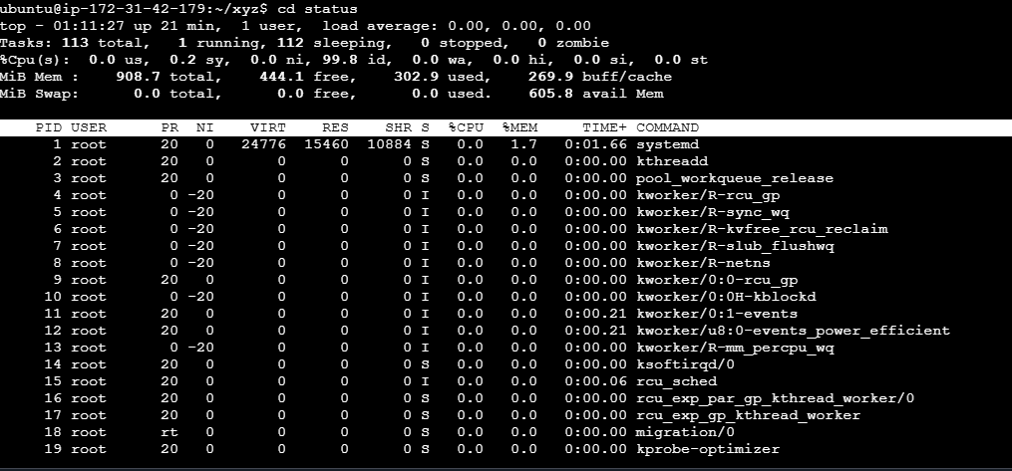
Using htop
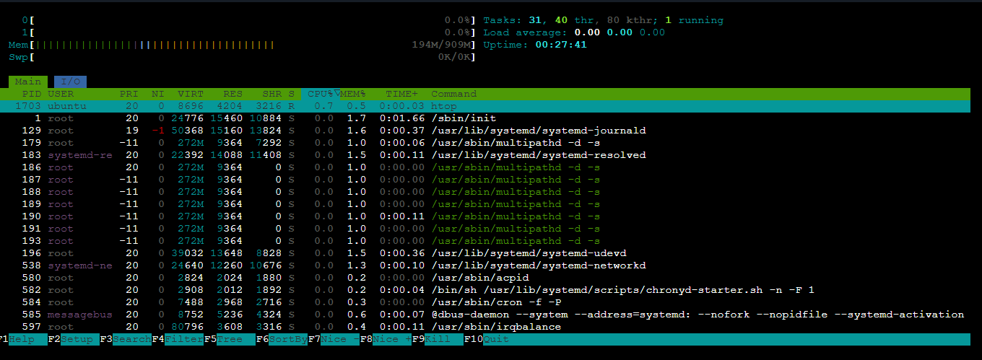

23. Create and manage user groups.
Created group and viewed all groups
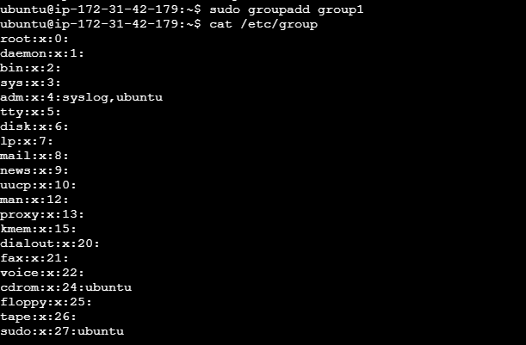
Added user to group and removed from group
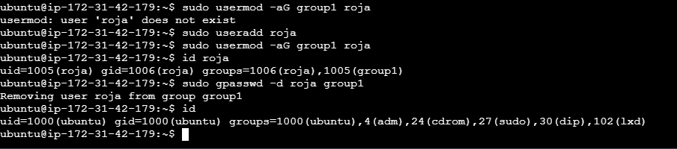
24. Set up SSH password less authentication.

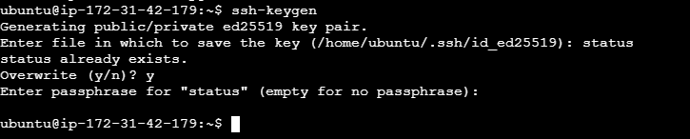

25. Compress and decompress files using tar.
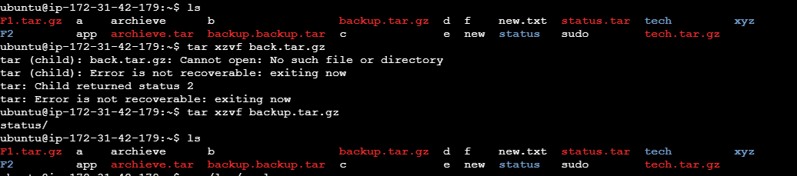
26. Monitor log files using tail or grep.

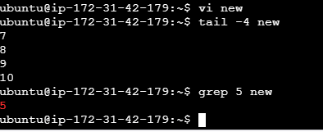
27. Set up a web server (e.g., Apache or Nginx).

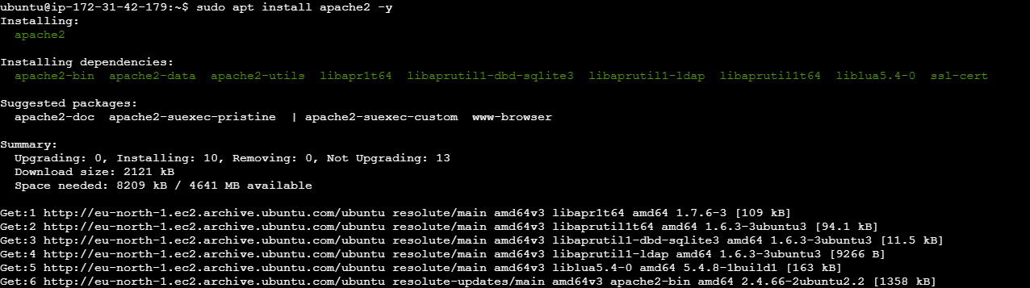
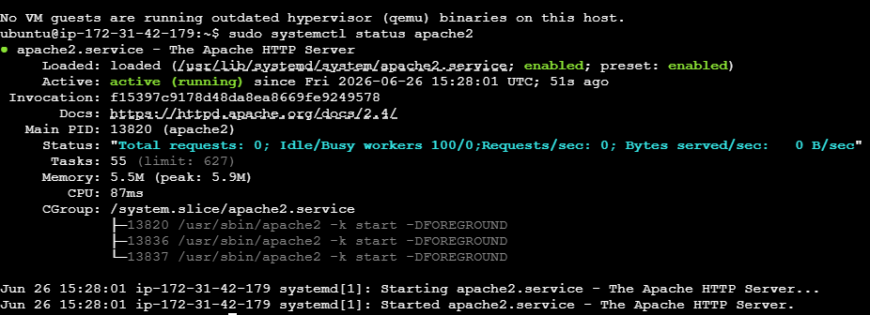

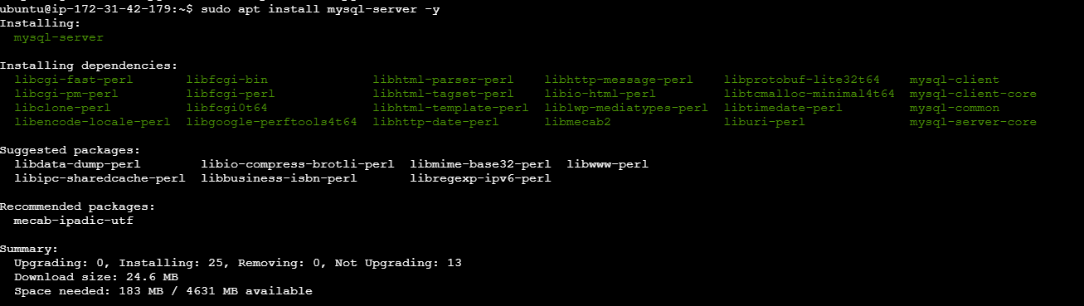
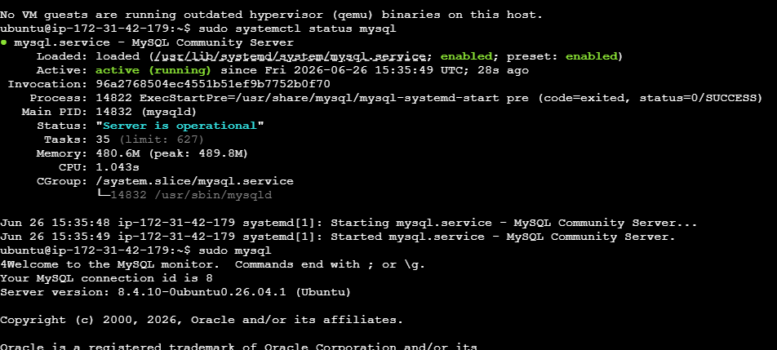

28. Configure and secure a MySQL Database.

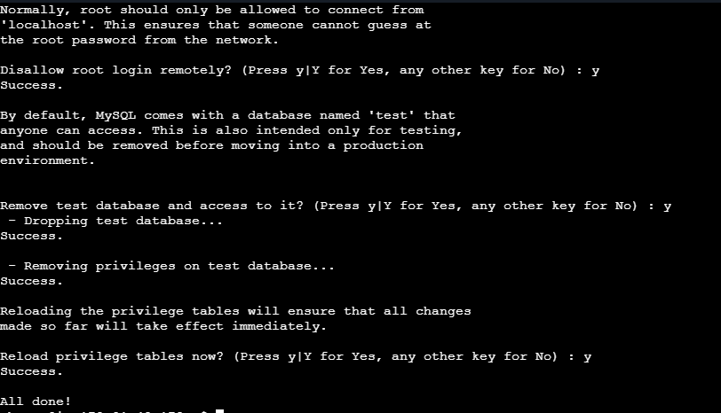
29. Set up a Application Server (e.g.,Apache Tomcat)
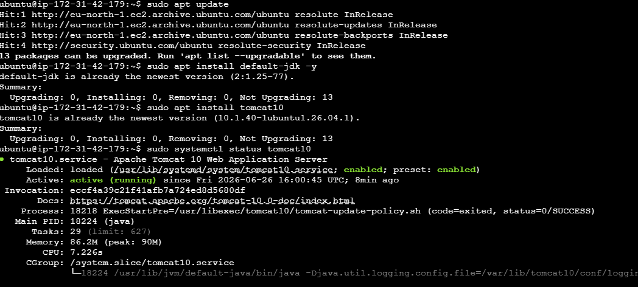

30 Set up a Application Server (e.g.,Apache Tomcat)

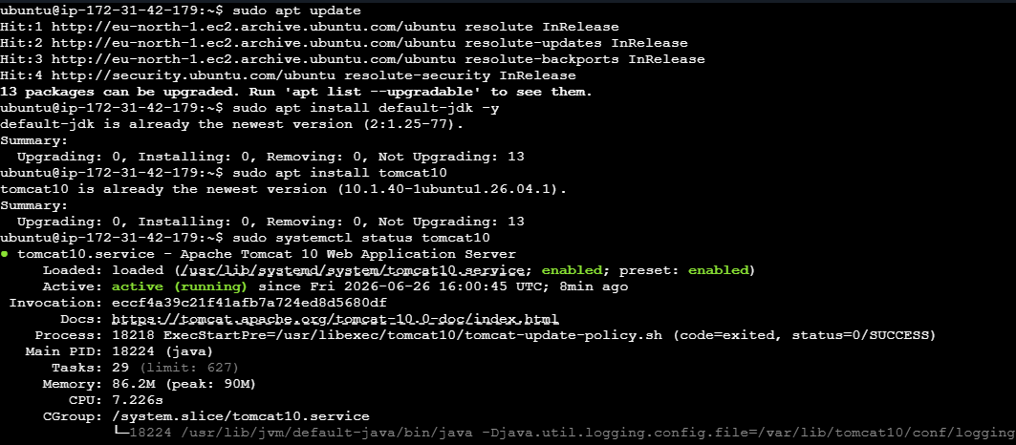

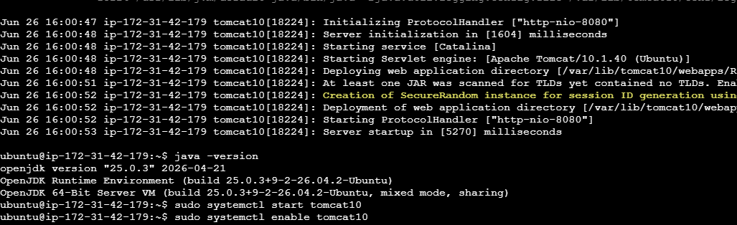
31. create a service file for Apache Tomcat.(Should execute by using systemtctl command)

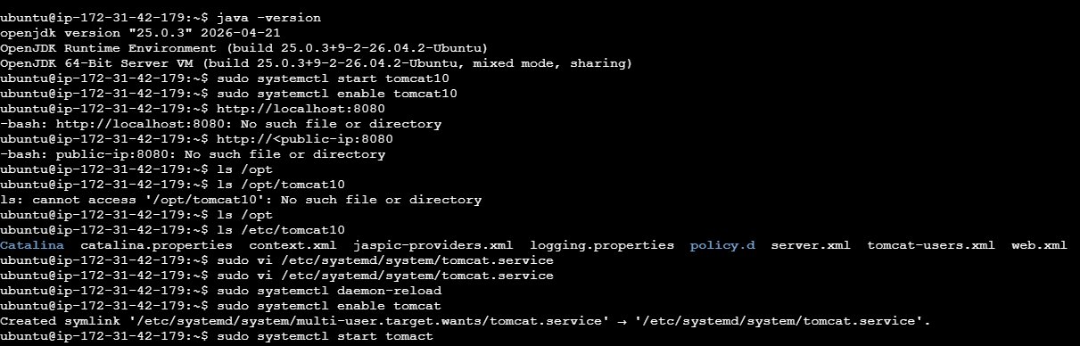

32. Print specific columns from a delimited file.

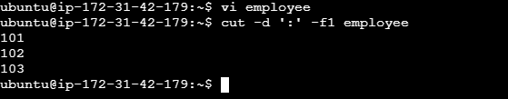

33. Filter and print lines based on a specific pattern or condition.

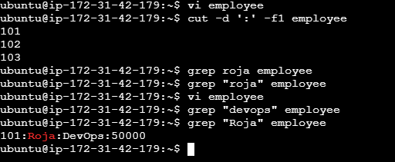

34. Calculate and print the average, sum, or other statistics of a column.

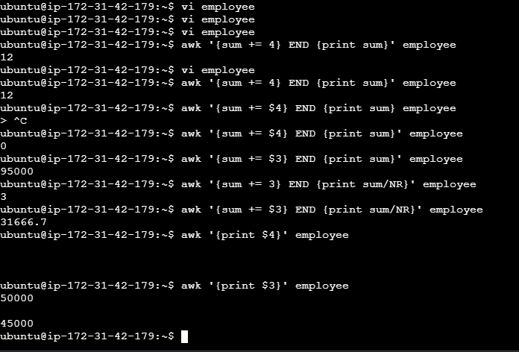

35. Perform string manipulation, such as extracting substrings or changing case.

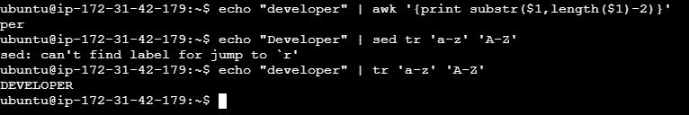

36. Count the occurrences of a specific pattern in a file.

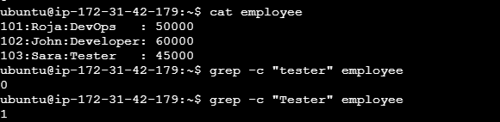

37. Sort lines based on a specific field or column.

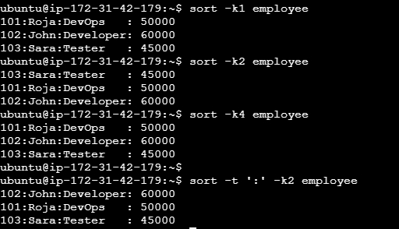

38. Substitute text in a file using search and replace.

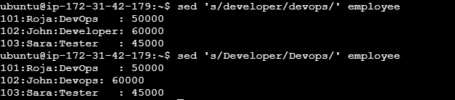

39. Delete specific lines based on a pattern or line number.

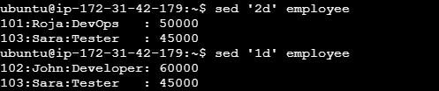

40. Append or insert text before or after a specific pattern or line.

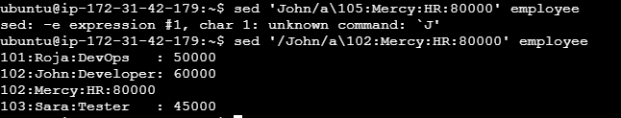

41. Print only specific lines from a file.

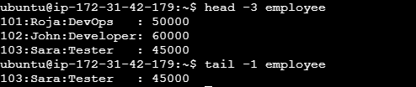

42. Copy file from linux to windows machine
Step-1 : Downloaded and installed WinSCP on Windows desktop
Step:2 : After opening, it asks for Host name, user name and password.
Provided Host name: ip-172-31-42-179
User name : Ubuntu and password and clicked on login

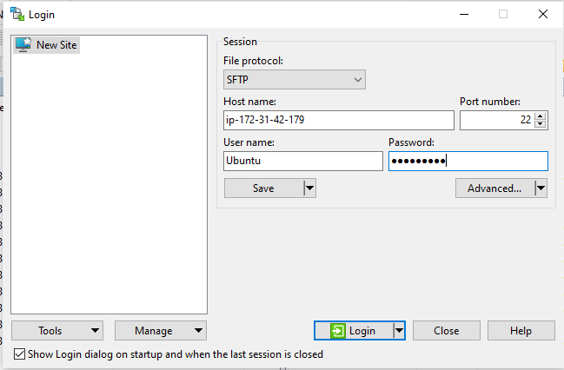

After connecting to server use this command
scp -i "C:\Users\DELL\Downloads\mykey.pem" ubuntu@13.234.100.25:/home/ubuntu/Documents/roja.txt "C:\Users\DELL\Desktop\"
to copy file from left window to right window so that the file will be copied to windows from linux.

42. 5 use cases for AWK and 5 use cases for sed
Awk use cases:

1. Used command awk -F ‘:’ ‘{print $2}’ employee to print second column.
o/p = Roja
John
Sara
Arjun
Mercy

2. Used command awk -F ‘:’ ‘{sum += $5} END {print sum/NR}’ employee to perform average of fifth column
o/p=0, as there is no fifth column

3. Used command awk ‘END {print NR}’ employee to count number of rows
o/p= 5, as there are 5 rows

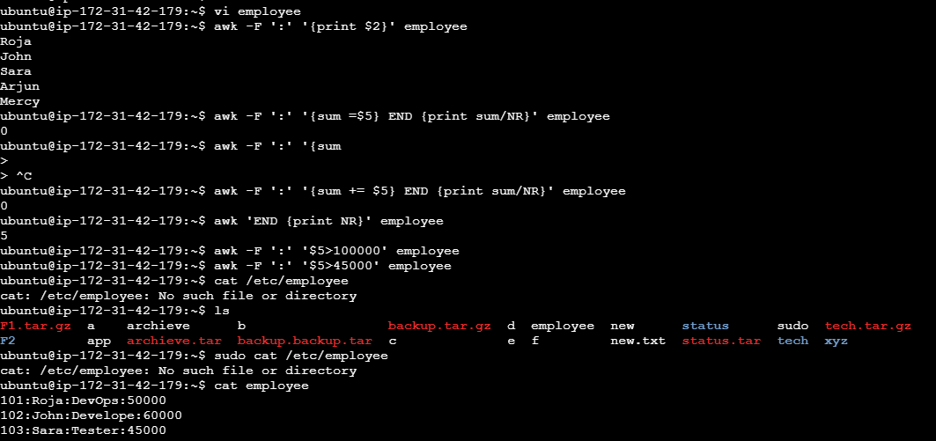

4. Used command awk –F ‘:’ ‘$4>60000’ employee to get those lines whose salaries are greater than 60000
o/p = 104:Arjun:HR:80000
105:Mercy:Analyst:100000
5. Used command awk -F ':' '$2=="Mercy"' employee to print the row where there is Mercy
o/p= 105:Mercy:Analyst:100000
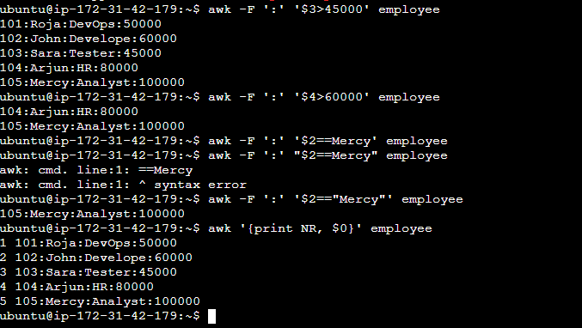
Sed use cases:
Apple:Tomato:Milk:Greengram:Kitkat
Banana:Chilli:Curd:Redgram:Munch
kiwi:Potato:Ghee:Yellowgram:Perk
Grapes:Cabbage:Cheese:Blackgram:Cadbury
Orange:Lemon:Butter:BBengalgram:Dairymilk
1. To replace Milk with Paneer used the command sed 's/Milk/Paneer/' chart and got output as
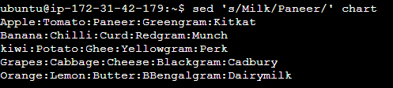

2. To add prefix popcorn: at the beginning of each row used sed 's/^/Popcorn:/' chart and received output as:
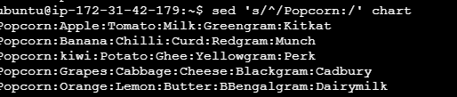

3. To print only the 3rd row used the command sed -n '3p' chart and received output as:

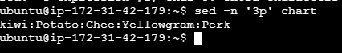

4. To print only the chocolates used sed 's/.*:\([^:]*\)$/\1/' chart and below is the output:

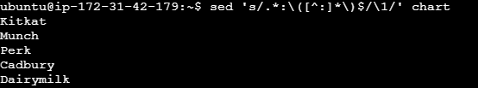

5. To delete last row used sed '$d' chart and the output where first row is deleted

